Q3 Physical Science
Science Georgia Standards of Excellence

S5P2. Obtain, evaluate, and communicate information to investigate electricity.
a. Obtain and combine information from multiple sources to explain the difference between naturally occurring electricity (static) and human-harnessed electricity.
b. Design a complete, simple electric circuit, and explain all necessary components.
c. Plan and carry out investigations on common materials to determine if they are insulators or conductors of electricity.

S5P3. Obtain, evaluate, and communicate information about magnetism and its relationship to electricity.
a. Construct an argument based on experimental evidence to communicate the differences in function and purpose of an electromagnet and a magnet. (Clarification statement: Function is limited to understanding temporary and permanent magnetism.)

b. Plan and carry out an investigation to observe the interaction between a magnetic field and a magnetic object. (Clarification statement: The interaction should include placing materials of various types (wood, paper, glass, metal, and rocks) and thickness between the magnet and the magnetic object.)
CIRCUITS WILL BE CREATED DURING STATIONS IN MATH/SCIENCE GUIDED MATH GROUPS:
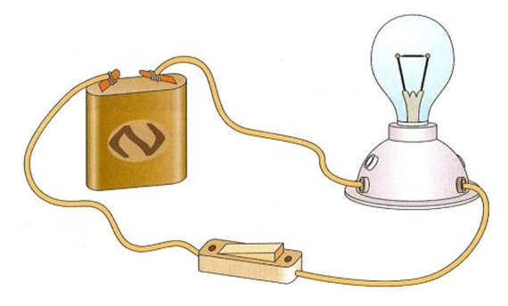

ELECTROMAGNET WILL BE CONSTRUCTED DURING OUR STEM DAY IN FEBRUARY:
