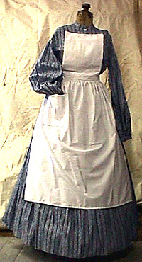[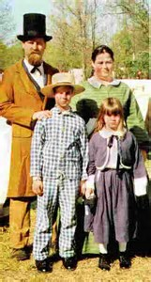](https://www.bing.com/images/search?view=detailV2&ccid=8Rl2LMHT&id=E42CED127A2D80CC6042FC893523749264404BB4&thid=OIP.8Rl2LMHTM4cEcpFEzUBw_AChEs&q=civil+war+clothing&simid=608021011219483646&selectedIndex=92)[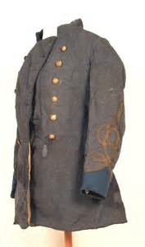](https://www.bing.com/images/search?view=detailV2&ccid=s1zEszC5&id=63BFA143B0218095A78950C0D93B6A0B7FCB8DF0&thid=OIP.s1zEszC5ZM0KfGQj0dGwdACxEs&q=civil+war+clothing&simid=608030829535298708&selectedIndex=168)

[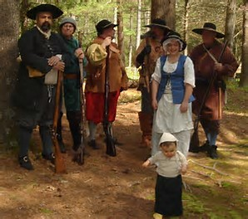](https://www.bing.com/images/search?view=detailV2&ccid=UndtN7lA&id=46564147CC7F0B5B16E659F4DA11AE32C2211583&thid=OIP.UndtN7lA4OCjVyp890scFQEsEK&q=civil+war+clothing&simid=608025413561157118&selectedIndex=158)[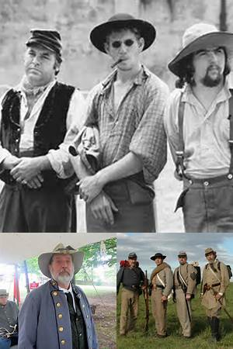](https://www.bing.com/images/search?q=Civil+War+Re-Enactors+Clothing&FORM=IRIBQP)

[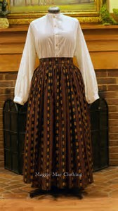](https://www.bing.com/images/search?view=detailV2&ccid=CYa5bQ%2ba&id=A12AB6A2BA6164A2DEF97FABBCCA69562A21DEC1&thid=OIP.CYa5bQ-azoe_LRfdOgKzlgCoEs&q=civil+war+clothing&simid=607987862695052048&selectedIndex=185)[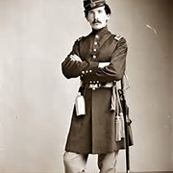](https://www.bing.com/images/search?q=Clothing+for+Civil+War+Soldiers&FORM=IRBPRS)[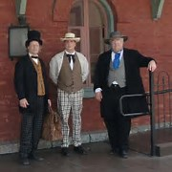](https://www.bing.com/images/search?q=Men's+Civil+War+Civilian+Clothing&FORM=IRBPRS)[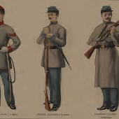](https://www.bing.com/images/search?q=Civil+War+Confederate+Clothing&FORM=IRBPRS)[](https://www.bing.com/images/search?view=detailV2&ccid=12Sz9gCp&id=D52588400D4A6C66EABCA56C3E09F0C05E875D56&thid=OIP.12Sz9gCpgGQ0jaE24iH36gEyDM&q=civil+war+clothing&simid=608054288637100497&selectedIndex=63)[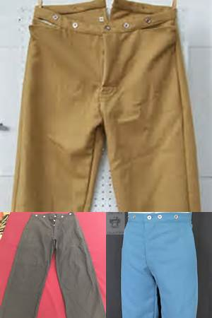](https://www.bing.com/images/search?q=Civil+War+Pants+Men&FORM=IRIBIP)