Measurement 32%
& Geometry 10%

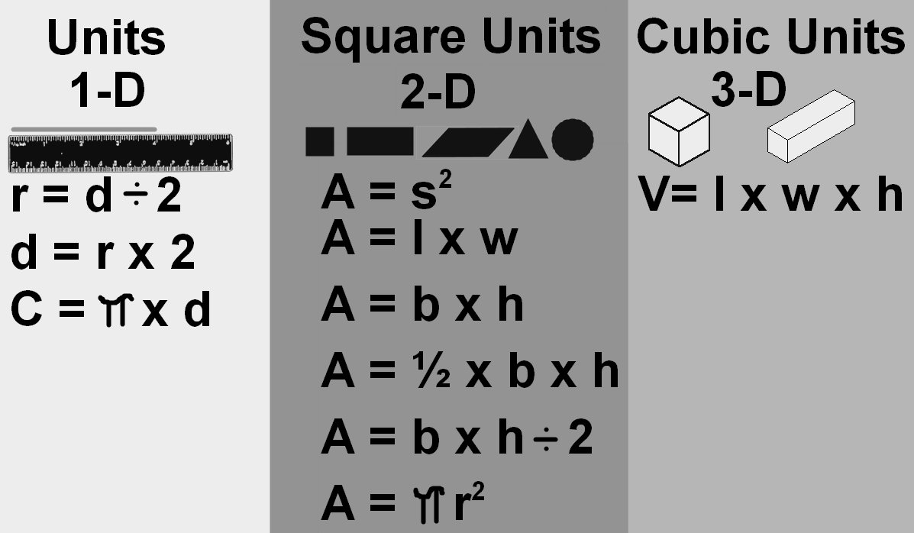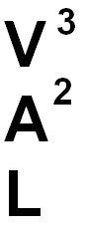

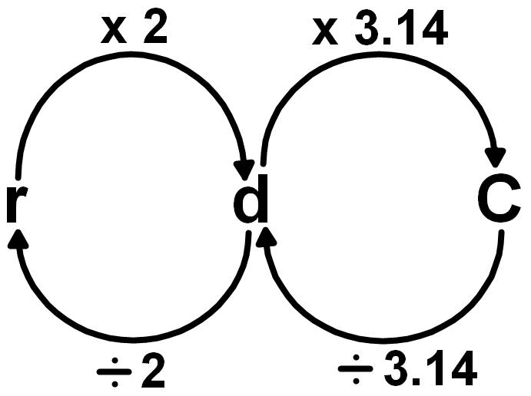
π

use 3.14 most of the time use 3 to estimate
3-D or 3 Dimensional Volume of a Prism:
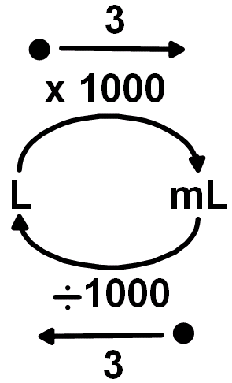
V= l x w x h

2-D or 2 Dimensional
Area of a Square: A = s²
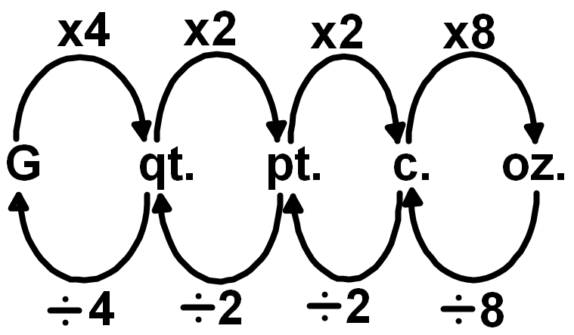
A = l x w A = b x h

Area of a Rectangle: A = l x w
A = b x h

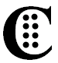
Area of a Parallelogram: A = b x h

Area of a Triangle: A = ½ x b x h
A = b x h ÷ 2

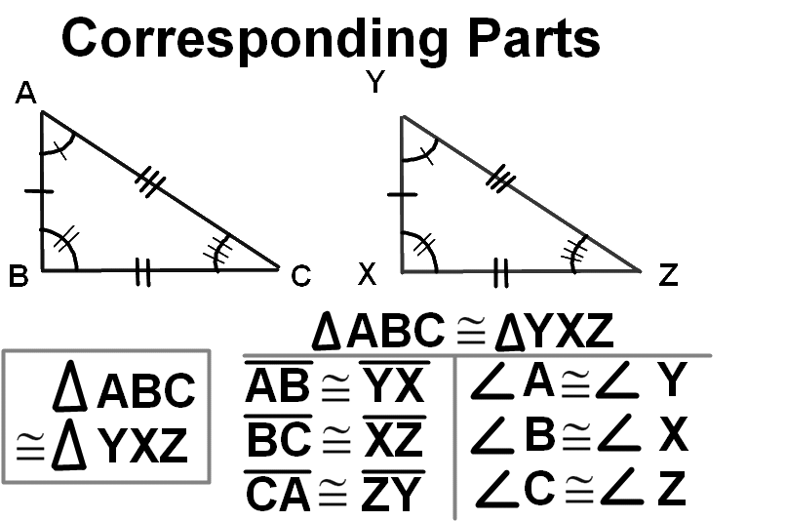
3 diameters is almost a Circumference!
Area of a Circle: A = π x r²
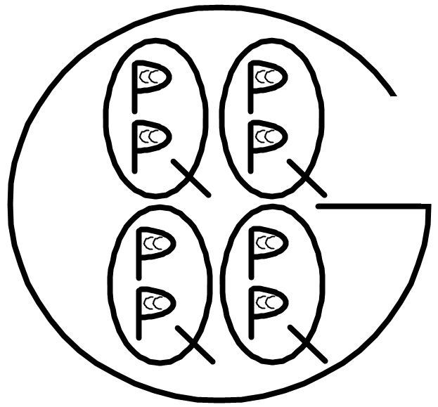
Use 3.14 for π
1-D or 1 Dimensional Radius: Diameter: r = d ÷ 2 d = r x 2
Circumference of a Circle: C = π x d
Use 3.14 for π

Number Sense 38%
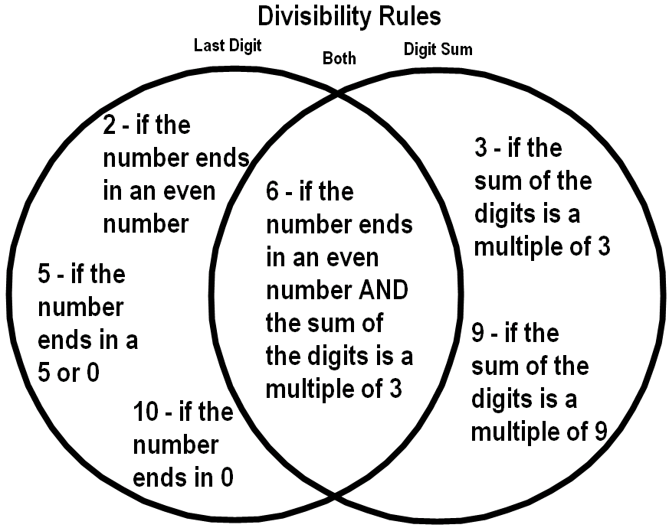
Fraction Bar Means Divide
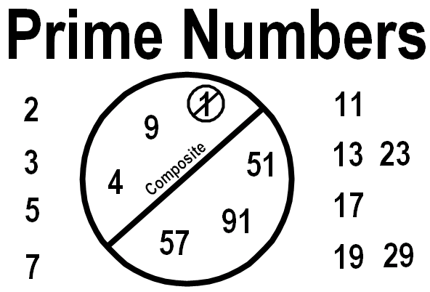
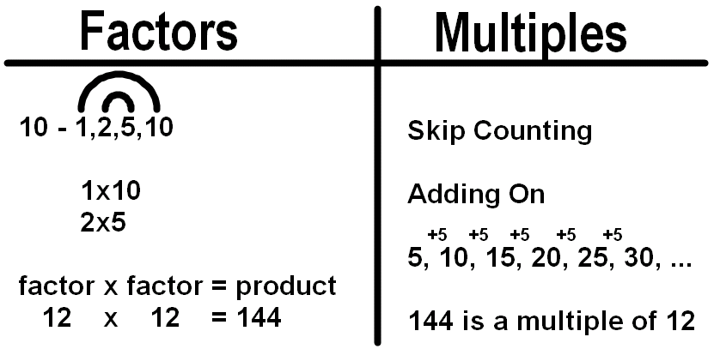
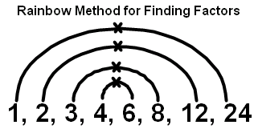
½ = 1÷2 = 0.5
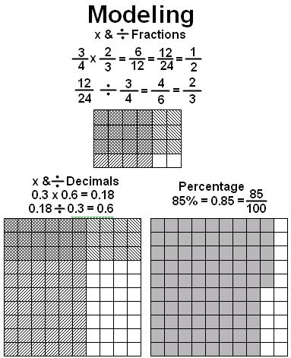

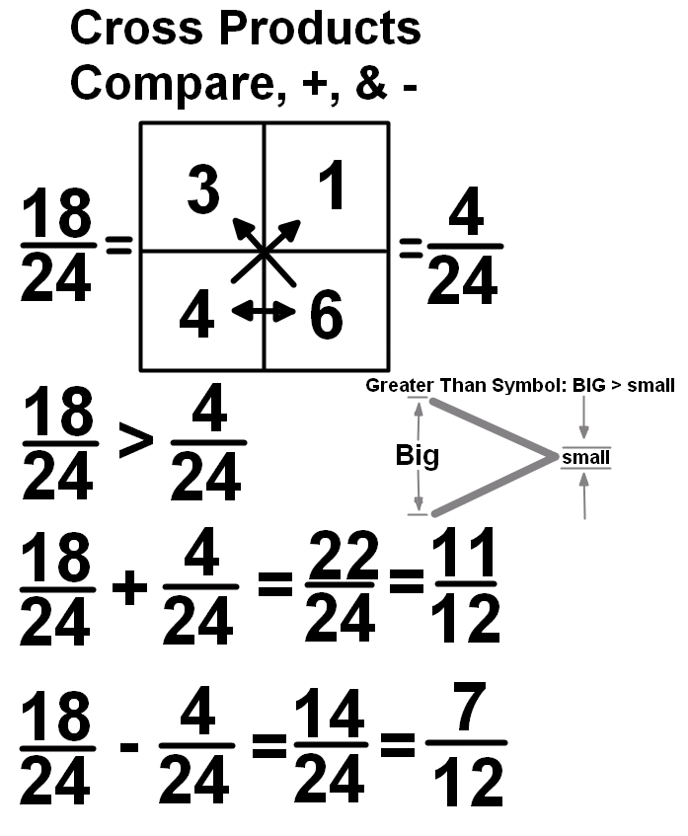
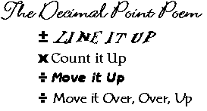
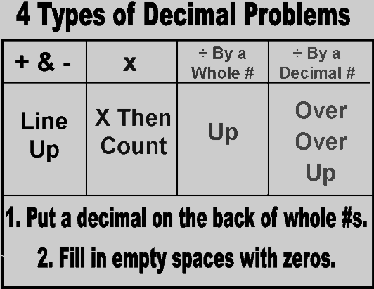
Data 10%

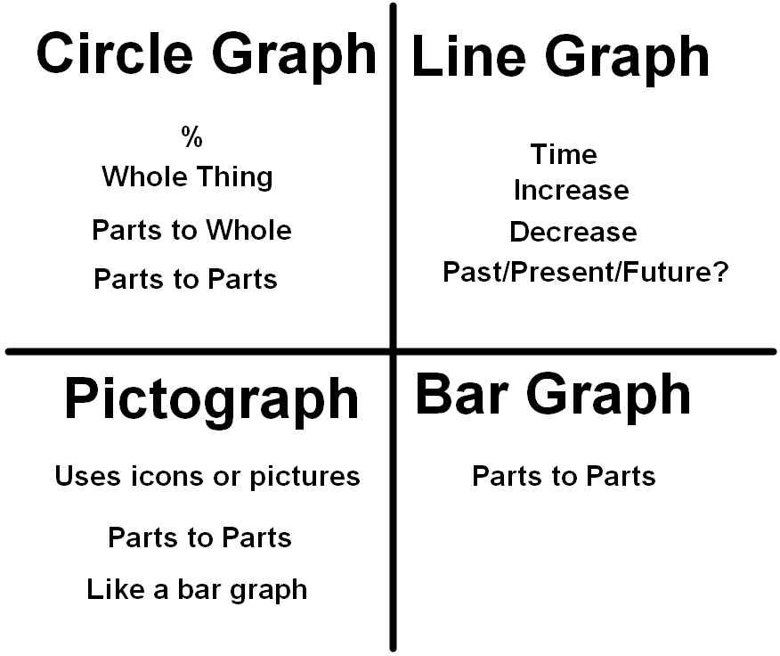

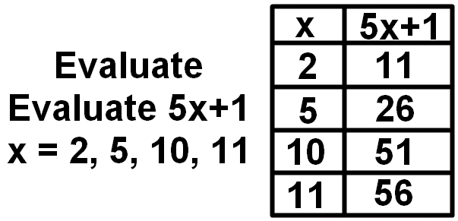
Algebra 10%

Numbers and Operations 38%
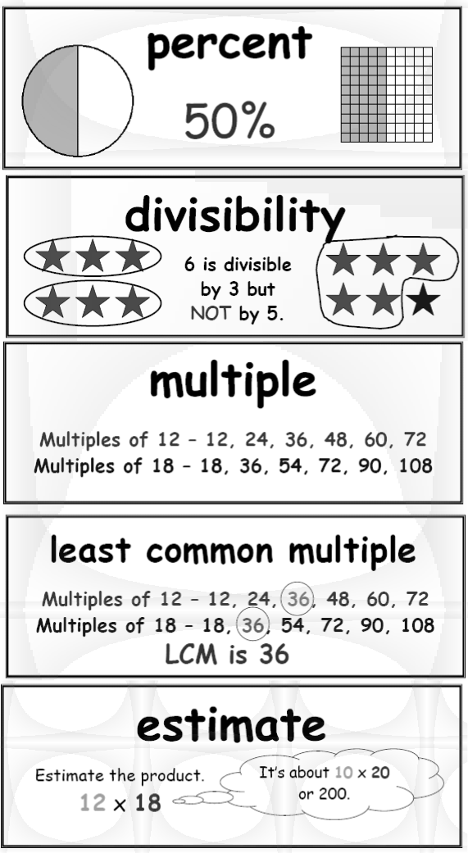
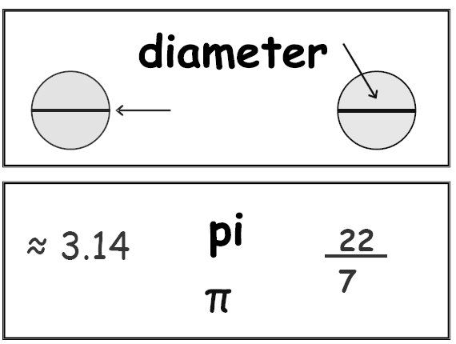
Geometry 10%
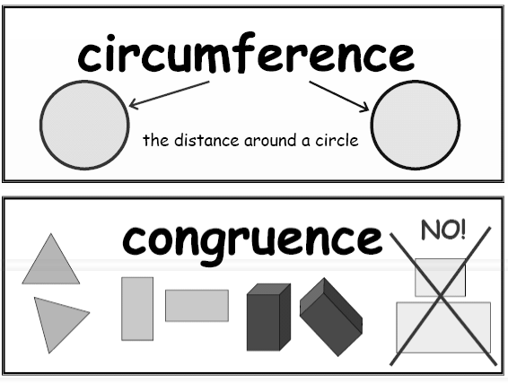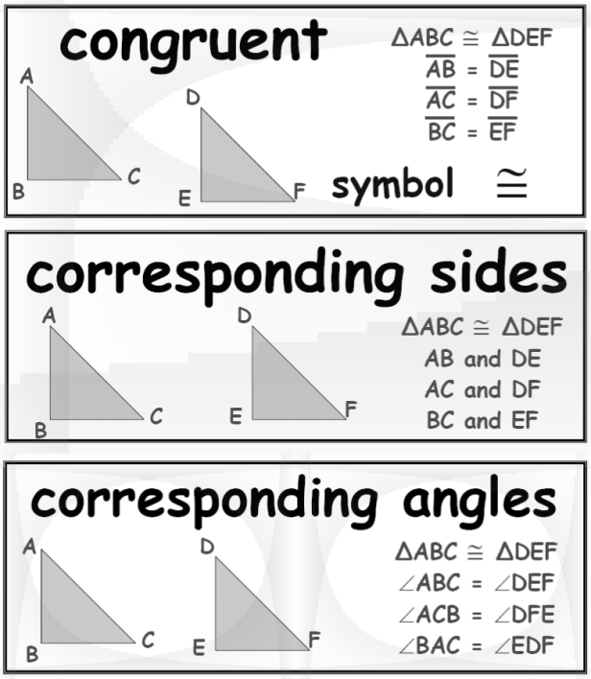

Algebra 10%

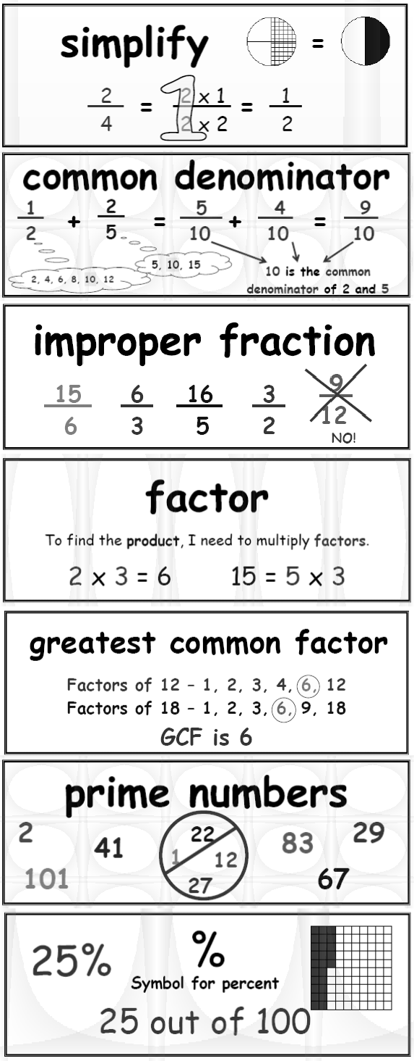
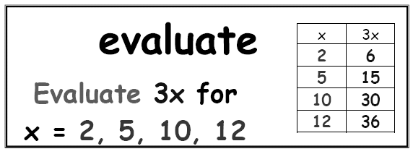

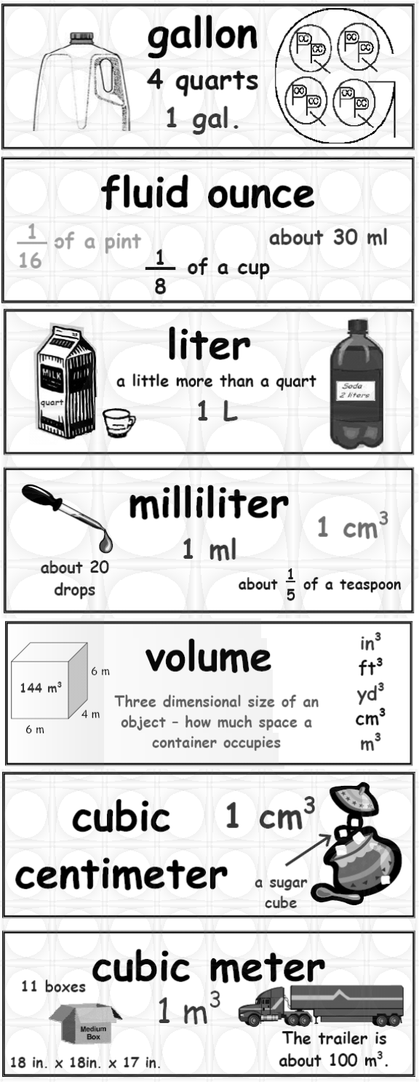
Data Analysis 10%
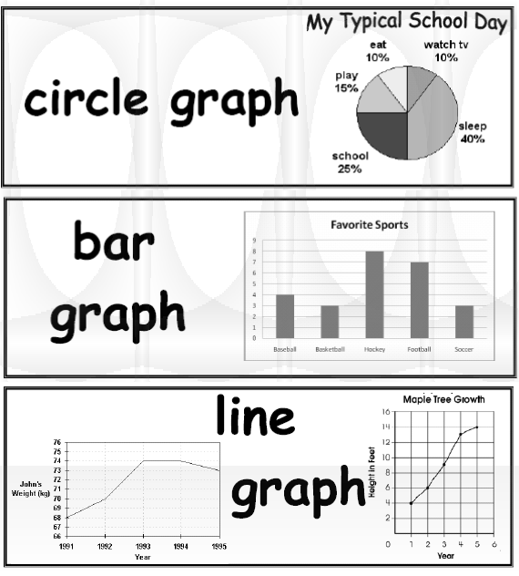

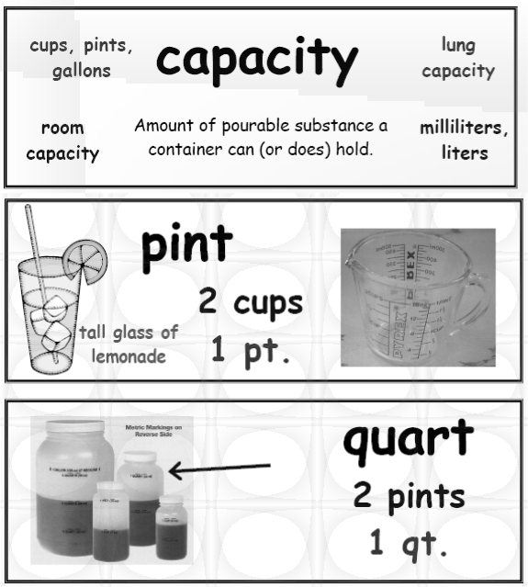
Measurement 32%
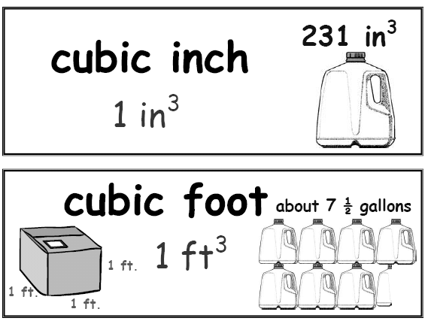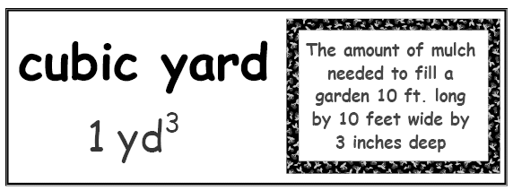

RESOURCES:

Moby Max
www.mobymax.com

Math CSI
Parent/Student Newsletters http://www.ceismc.gatech.edu/#

Sample CRCT 5th Grade Questions: https://www.georgiastandards.org/ Frameworks/Pages/BrowseFramew orks/mathK-5.aspx

Other 5th Grade Resources http://www.gcbe.org/education/co mponents/links/links.php?sectionde tailid=28337

